[**AWS Serverless**](https://confluence.ellucian.com/display/PD/AWS+Serverless)

**AWS Serverless Assignments**

1. Create a Lambda function: Start by creating a simple Lambda function in JavaScript. You can write a function that takes a string (The input string has to be passed within the event object to the lambda) and returns a new string with all the vowels removed. Test your function using the AWS Lambda console. c

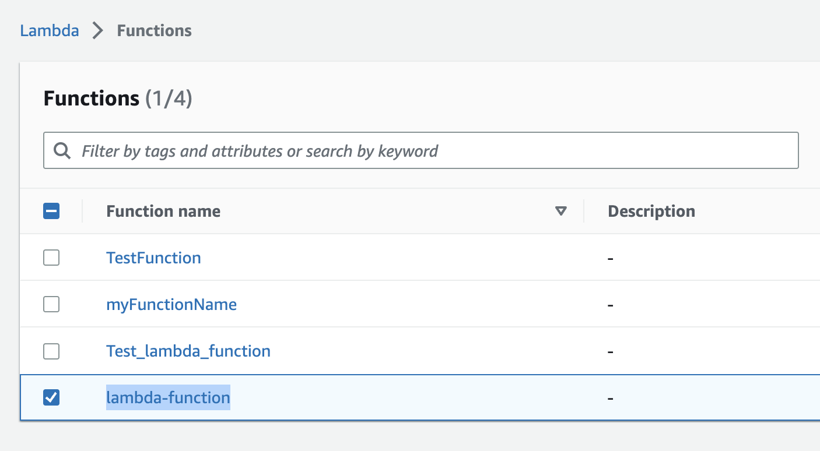

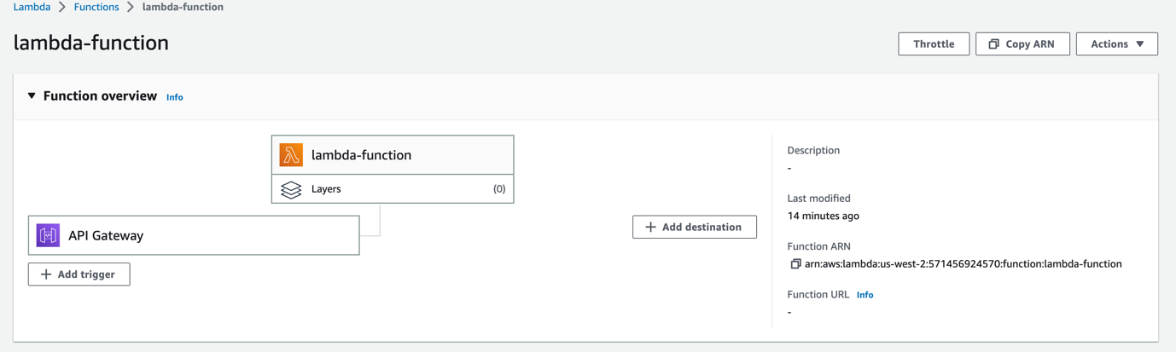

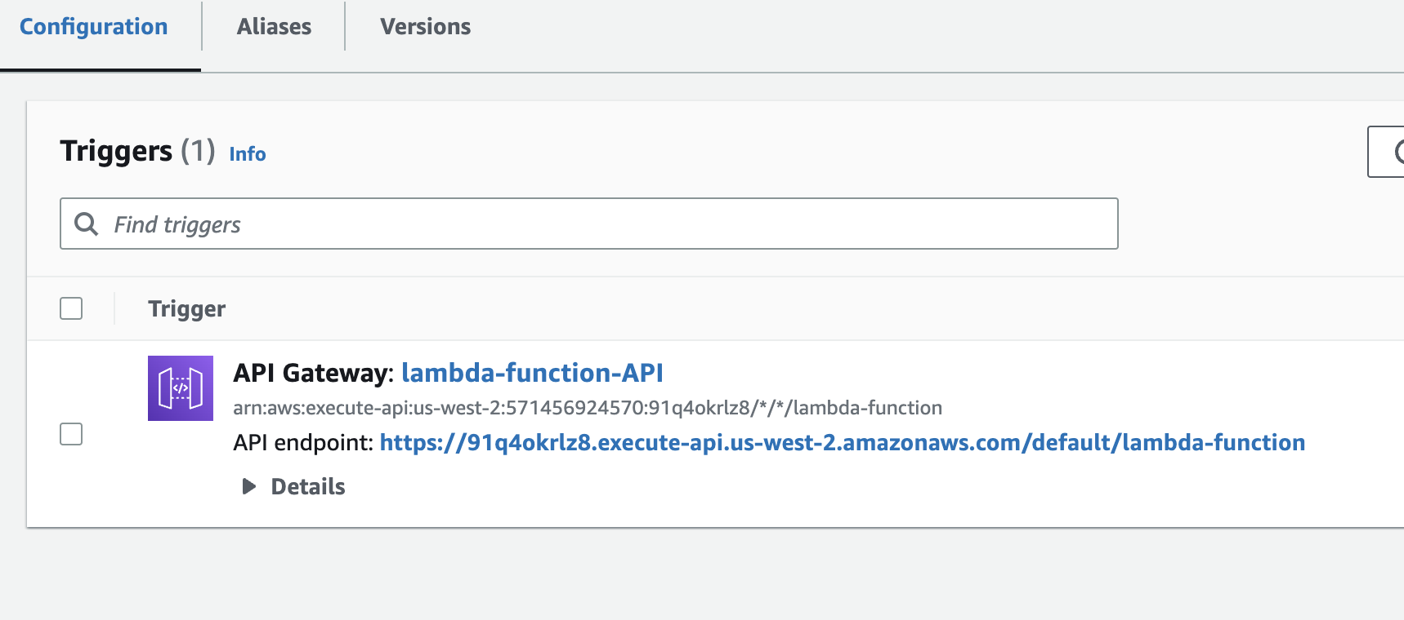

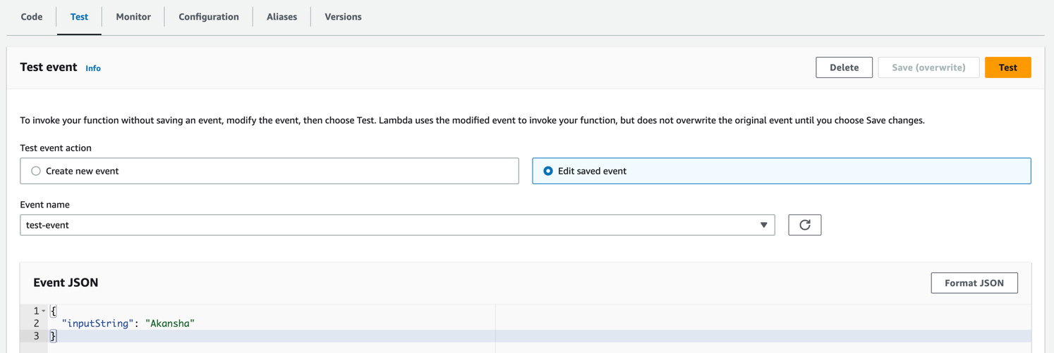

2. Trigger the Lambda function using API Gateway: Create an API Gateway endpoint that triggers your above Lambda function (The input string has to be passed as an API Request parameter, Make proper changes in the lambda handler to process the event from API Gateway). Use the API Gateway console to create a new POST API and define a resource and method for your endpoint. c

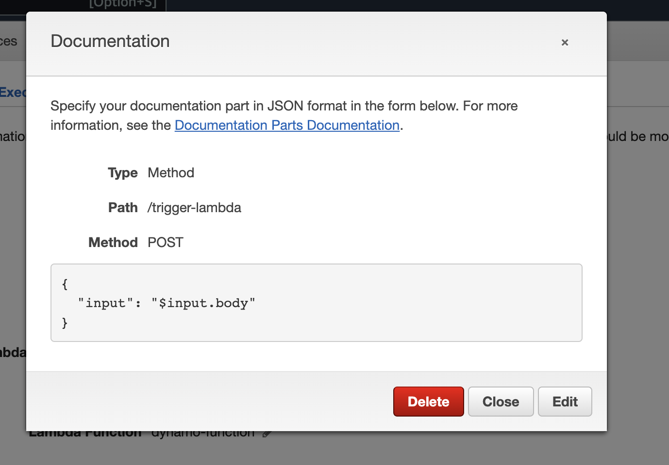

3. Store data in DynamoDB: Use AWS DynamoDB to store data for your Lambda function. Create a new DynamoDB table and write code to save and retrieve data from the table. ( Create a GET API using API Gateway. Write a method to retrieve data from DynamoDB on the GET request. Write a method to save the data after processing the input to DynamoDB on the POST request. Store data in DynamoDB as an object containing a unique id, the input string, and the output string ).

Dynamo DB table:

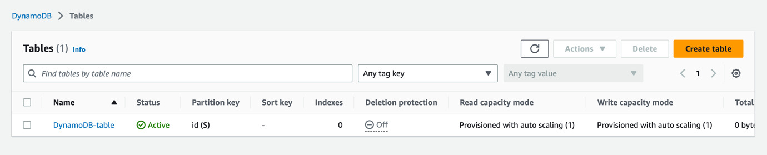

IAM Role

Lambda Function

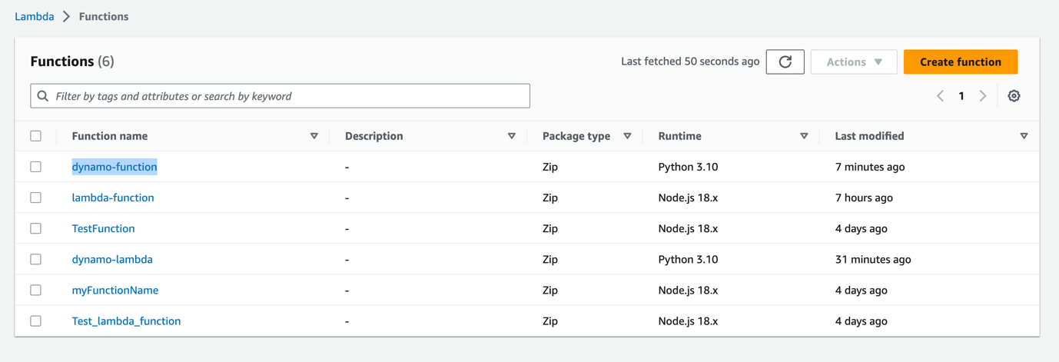

Creating API

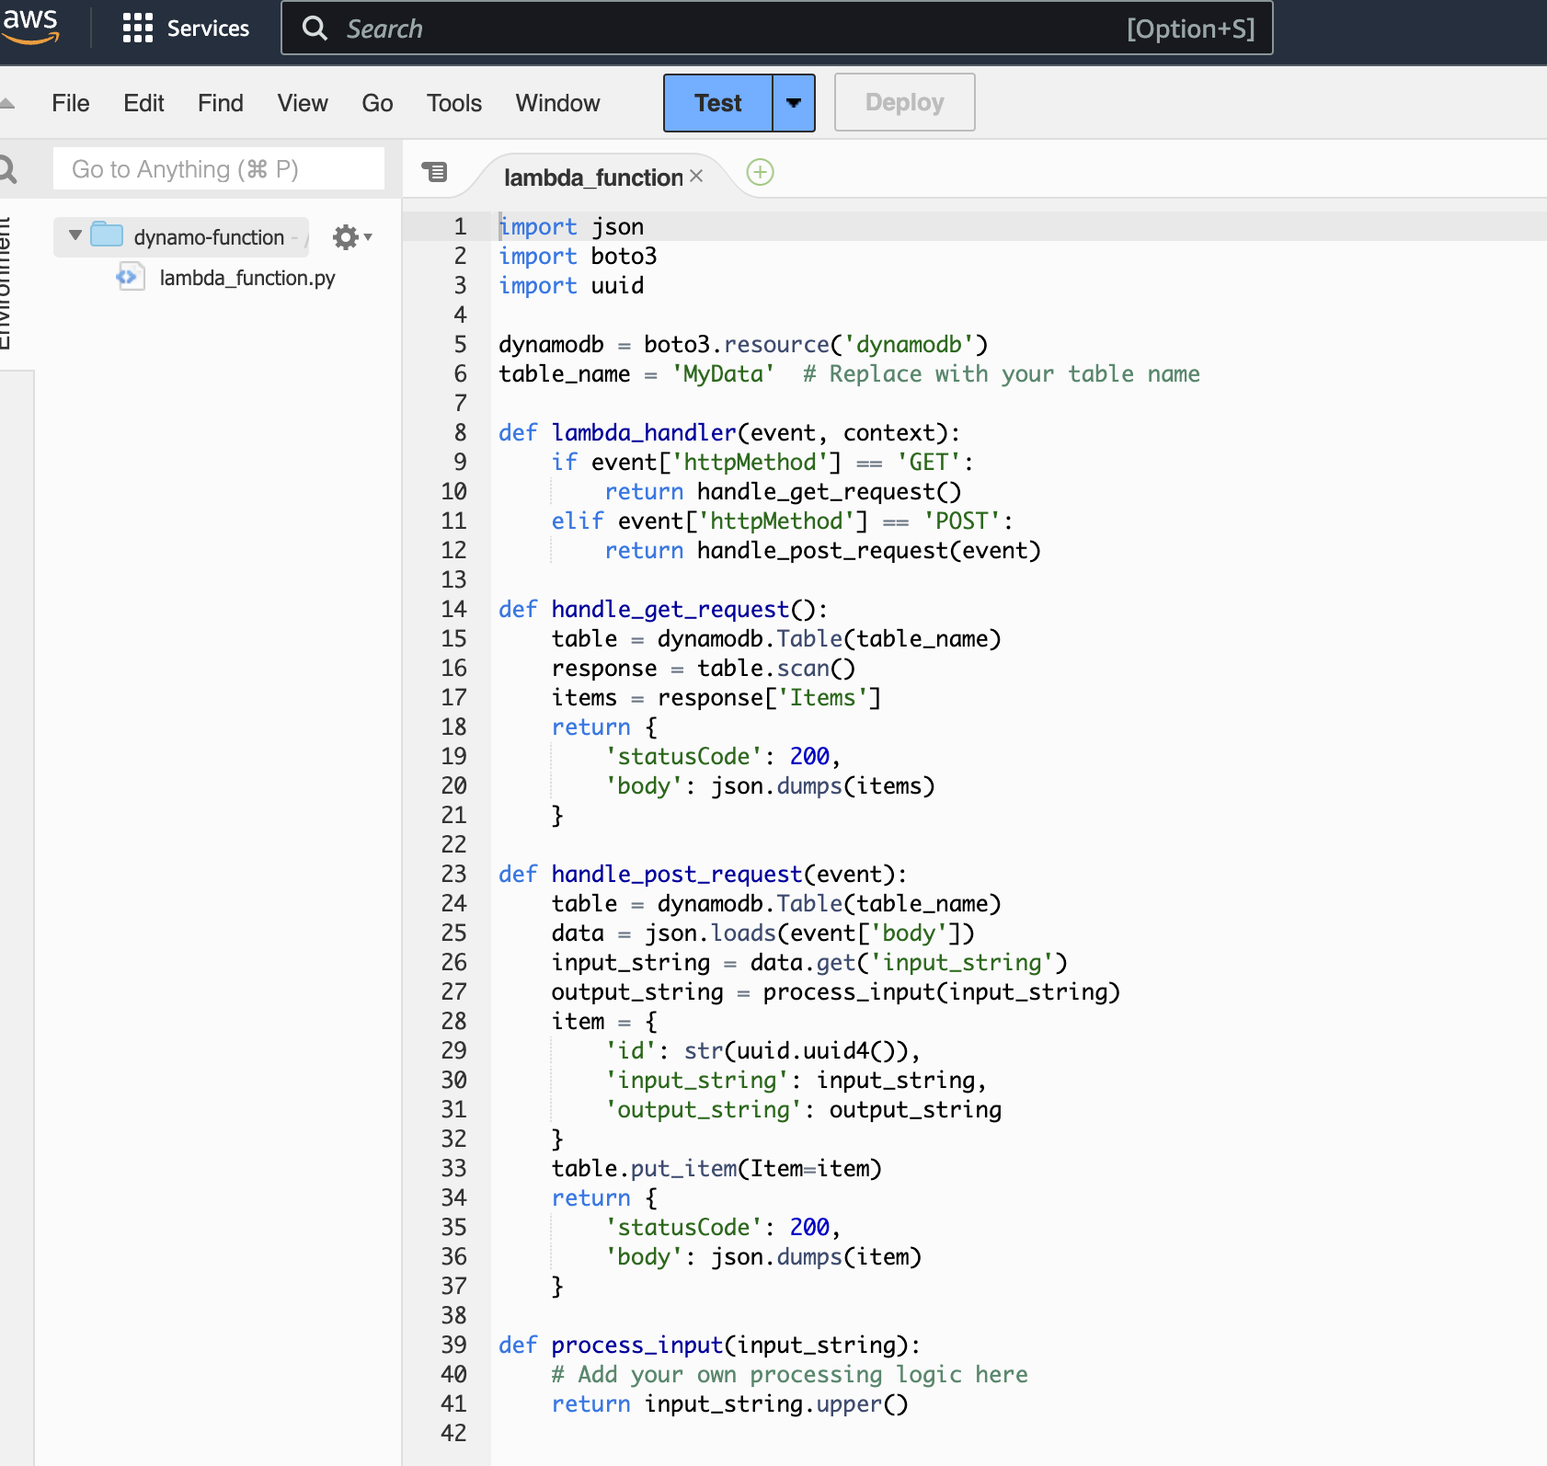

Deployment of API

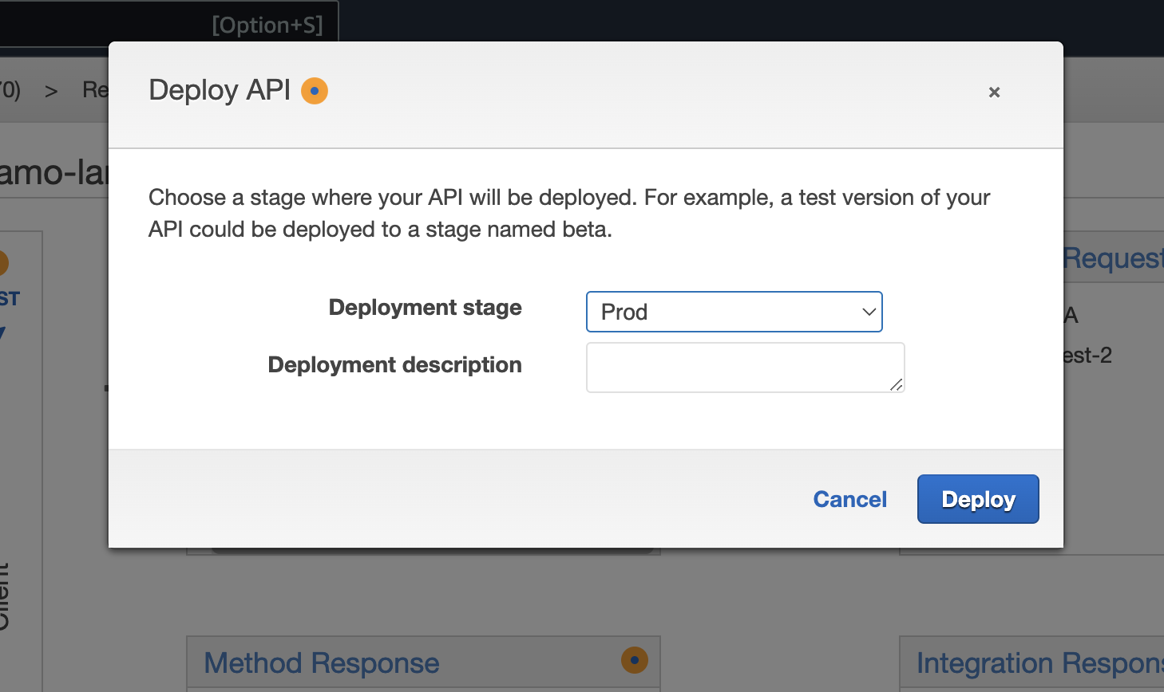

Endpoint generated for Prod env:

